Article
Machine Learning and Mobile Applications for Emotion Recognition in Children with Autism Spectrum Disorder: A Systematic Literature Review
Jorge Eduardo Castañeda Alban ¹*, Jhafet Martín Cánepa Maceda ¹ and Christopher Antonio Pillihuamán Santiago ¹
Received: date
Revised: date
Accepted: date
Published: date
Citation: To be added by editorial staff during production.
Copyright: © 2025 by the authors. Submitted for possible open access publication under the terms and conditions of the Creative Commons Attribution (CC BY) license (http://creativecommons.org/licenses/by/4.0/).
¹ Universidad San Ignacio de Loyola, School of Engineering, Information Systems Engineering Program, Lima, Peru; jcastaneda@usil.edu.pe (J.E.C.A.); jhafet.canepa@usil.pe (J.M.C.M.); c.pillihuaman@usil.pe (C.A.P.S.)
* Correspondence: jcastaneda@usil.edu.pe; Tel.: +51-939-844-835
Abstract
Emotion recognition deficits constitute a critical barrier to social development in children with Autism Spectrum Disorder (ASD), yet evidence-based technological interventions remain scarce, particularly in resource-limited settings. This systematic review synthesizes current evidence on Machine Learning technologies applied to emotion recognition and ASD detection, emphasizing mobile applications and neural network architectures. Following PRISMA 2020 methodology, we conducted exhaustive searches across three indexed databases (IEEE Xplore, Scopus, Web of Science), identifying 188 initial records. After applying rigorous inclusion criteria through systematic screening phases, 42 relevant studies published between 2019-2024 were selected for qualitative synthesis. Findings reveal that customized CNN architectures achieve accuracy exceeding 90% in facial recognition tasks, while real-time mobile applications attain 75-88% detection precision. However, critical limitations persist: 89% of studies focus on pediatric populations under 12 years, 76% require constant connectivity, and no studies validate models in Latin American populations. The evidence base demonstrates substantial methodological heterogeneity across datasets, evaluation protocols, and population characteristics, necessitating cautious interpretation when comparing reported metrics. This review identifies fundamental gaps in child-focused ASD interventions, establishing methodological foundations for developing accessible, culturally adapted therapeutic tools validated in resource-limited contexts and informing future research directions in this underserved area.
Dataset: Not applicable (systematic review). All extracted data available in supplementary materials upon publication.
Dataset License: Not applicable.
Keywords: autism spectrum disorder; emotion recognition; machine learning; convolutional neural networks; mobile applications; systematic review; assistive technology; low-resource settings; pediatric population.

1. Introduction
Autism Spectrum Disorder (ASD) represents a neurodevelopmental condition affecting approximately 1% of the global population, characterized by persistent deficits in reciprocal social communication and restrictive behavioral patterns [12]. Among the core manifestations of ASD, difficulties in recognizing and processing facial emotional expressions emerge as one of the most robust predictors of social development challenges, directly affecting educational outcomes, peer relationships, and family dynamics throughout childhood and adolescence [1,6,10]. Despite its prevalence and developmental impact, therapeutic interventions for children with ASD show considerable variability in accessibility and cultural adaptation, particularly in resource-limited settings, configuring a critical care gap [14,18].
Research using eye-tracking and wearable technologies documents that individuals with ASD exhibit atypical visual exploration patterns during emotional face processing, characterized by reduced fixations on the ocular region and fragmented processing of facial configurations [5,6,35]. These neurobiological alterations correlate significantly with deficits in emotion recognition (r = -0.67, p < 0.001) and theory of mind, fundamental cognitive mechanisms for effective social interaction [35]. Consequently, children with ASD face substantial challenges in social skill development, peer integration, and adaptive functioning that persist into adulthood, where unemployment rates exceed 85% in middle-income countries [18].
The convergence of advances in Machine Learning, particularly in Convolutional Neural Networks (CNN), and the ubiquity of mobile devices has generated unprecedented opportunities to develop objective, scalable, and accessible therapeutic interventions for pediatric populations. Customized CNN architectures have demonstrated outstanding capabilities in facial expression classification, achieving accuracy exceeding 94% on standardized datasets [1,10,25]. Specifically, transfer learning-based models with ResNet-50 and VGGFace architectures enable adaptation to individual characteristics of the autism spectrum through fine-tuning with reduced samples, overcoming generalization limitations observed in traditional approaches [5,25,31].
Concurrently, mobile devices emerge as ideal platforms for continuous ecological interventions in child-focused applications, given their low cost, portability, and real-time processing capacity. Mobile systems integrating emotion recognition algorithms via OpenCV and TensorFlow Lite have demonstrated clinical feasibility in naturalistic settings [6,10], while applications with automated video analysis achieve 88% sensitivity and 82% specificity in detecting ASD behavioral markers in pediatric populations [5,41]. However, published studies present significant methodological heterogeneity regarding architectures used, evaluation metrics reported, dataset characteristics employed, and target populations, limiting direct comparability of findings and hindering identification of best practices [2,12].
Despite these technological advances, translating research into clinical practice faces critical barriers in resource-limited contexts. Seventy-six percent of ASD applications developed require constant internet connectivity, precluding their use in regions with deficient infrastructure [9,22]. Additionally, 89% of studies focus on pediatric populations under 12 years, reflecting the concentration of research efforts in early childhood intervention [14,18]. Critically, no systematic review has synthesized evidence specifically oriented toward identifying technical characteristics, methodological limitations, and implementation gaps in Machine Learning mobile applications for emotion recognition in children with ASD, particularly considering the needs of resource-limited settings such as Latin America.
This systematic review addresses this gap through exhaustive analysis of Machine Learning technologies applied to emotion recognition and ASD detection in predominantly pediatric populations, formulating six specific research questions (Table 1). Our objective is to synthesize neural network architectures, performance metrics, datasets utilized, mobile application characteristics, and methodological limitations identified in the literature, establishing the current state of the art and identifying opportunities for developing culturally adapted therapeutic tools, validated in Latin American contexts and designed to operate in resource-limited technological environments. While the reviewed evidence focuses primarily on child populations, findings provide essential groundwork for understanding how these technologies might be extended or adapted for broader age ranges, including adolescents and adults where intervention needs remain pressing but clinically distinct.
Table 1. Methodological Foundations.
Motivation | Research Question
CNN architectures show accuracy variability (72-96%) depending on design, requiring identification of optimal configurations for ASD applications | What Machine Learning architectures and models demonstrate greater effectiveness in emotion recognition and ASD detection?
Heterogeneity in reported metrics (accuracy-only vs. F1-score) limits comparability between studies | What performance metrics are consistently employed to evaluate ML algorithms in clinical ASD contexts?
Absolute metric values vary according to target population (pediatric vs. adult) and evaluation conditions (laboratory vs. ecological) | What accuracy, precision, recall, F1-score, and AUC values do models achieve in different methodological configurations?
Western datasets (FER2013, CK+) present generalization limitations to Latin American populations, requiring identification of alternatives | What datasets are used for model training and validation, and what are their representativeness limitations?
Input variables (facial image-only vs. multimodal) affect prediction robustness, requiring identification of optimal configurations | What input variables or features do ML systems employ for ASD detection and evaluation?
Existing mobile applications present technical requirements (connectivity, hardware) that limit accessibility in resource-limited settings | What technical and methodological limitations impede ML system implementation in resource-limited contexts?

2. Materials and Methods

2.1. Research Questions and Theoretical Framework
Based on identified gaps in literature regarding ML applications for emotion recognition in ASD, we formulated six specific research questions (Table 2) designed to address both technical aspects (architectures, metrics, datasets) and implementation limitations in real clinical contexts. These questions were structured following a PICO framework adapted for technology reviews: Population (children with ASD), Intervention (mobile ML systems), Comparators (alternative architectures), Outcomes (performance metrics and implementation limitations).
Table 2. Research Questions.
Id. | Research Question | Justification
RQ1 | What are the algorithms, architectures, and models used for emotion recognition in children with ASD? | Identify technical configurations that guide design of systems optimized for ASD-specific emotional processing characteristics
RQ2 | What metrics are employed to evaluate performance of emotion recognition algorithms, methods, or models? | Determine evaluation standards facilitating cross-study comparability and clinical validation
RQ3 | What are the accuracy, precision, recall, F1-score, and AUC values of these models? | Quantify performance achieved by existing technologies to establish realistic benchmarks for new tool development
RQ4 | What datasets are used for training and validation of emotion recognition models in ASD? | Evaluate representativeness and generalization limitations of available datasets, especially regarding cultural and phenotypic diversity
RQ5 | What facial variables or features are employed in emotion recognition systems for children with ASD? | Identify optimal input features balancing diagnostic precision with mobile implementation feasibility
RQ6 | What are the main problems or limitations in implementing mobile applications for emotion recognition in resource-limited contexts? | Document technical, clinical, and accessibility barriers requiring attention for effective research-to-practice translation

2.2. Protocol and Registration
This systematic review was conducted following PRISMA 2020 guidelines for transparent reporting of systematic reviews. The review protocol was not prospectively registered in PROSPERO or similar registries, which represents a limitation in terms of methodological transparency and protection against post-hoc modifications. A complete PRISMA 2020 checklist is included as supplementary material to facilitate replication and methodological assessment.

2.3. Information Sources and Search Strategy
We conducted comprehensive searches across three major indexed databases: IEEE Xplore Digital Library, Scopus, and Web of Science Core Collection. The search covered publications from January 2010 to October 2025, encompassing journal articles and conference proceedings in computer science, biomedical engineering, and medical informatics domains. We restricted our search to open-access publications to ensure reproducibility and accessibility of included studies, acknowledging this introduces potential publication bias favoring studies with institutional OA funding. Grey literature sources (preprints, technical reports, dissertations) were not systematically searched due to resource constraints and quality assurance considerations, which may limit coverage of emerging unpublished findings.
The search strategy was developed iteratively through pilot searches and consultation with a medical informatics librarian. Using the most relevant terms related to our research domain, we constructed a comprehensive Boolean search string that was adapted and applied consistently across all three databases with platform-specific syntax adjustments
Core search string (Scopus syntax):
TITLE-ABS-KEY ( ( "autism spectrum disorder" OR "ASD" OR "autism" ) OR ( "emotion recognition" OR "facial expression" OR "emotional recognition" ) AND ( "machine learning" OR "deep learning" OR "CNN" OR "convolutional neural network" OR "artificial intelligence" ) AND ( "mobile application" OR "smartphone" OR "serious game" OR "digital intervention" ) ) AND ( LIMIT-TO ( OA , "all" ) ) AND ( LIMIT-TO ( DOCTYPE , "re" ) OR LIMIT-TO ( DOCTYPE , "cp" ) OR LIMIT-TO ( DOCTYPE , "ar" ) )
This search string was executed with equivalent Boolean operators and field codes in IEEE Xplore and Web of Science on October 15, 2025. The complete, platform-specific search strings for each database are provided in Supplementary Material S1. All searches were conducted by two independent researchers (J.M.C.M., C.A.P.S.) to ensure consistency and completeness.

2.4. Eligibility Criteria
Studies were included if they met the following criteria: (1) focused on emotion recognition or ASD detection using Machine Learning approaches; (2) employed mobile applications, smartphone-based systems, or technologies adaptable to mobile platforms; (3) reported quantitative performance metrics; (4) published in peer-reviewed journals or conference proceedings; (5) available as open-access full text; (6) written in English. We excluded: (1) review articles, systematic reviews, or meta-analyses; (2) studies without empirical validation; (3) studies focusing exclusively on non-facial modalities (e.g., voice-only, physiological signals without facial analysis); (4) duplicate publications of the same dataset or methodology.
Initially, we applied an additional criterion excluding studies without Scimago Journal Rank (SJR) indexing. However, recognizing that journal impact metrics measure publication venue prestige rather than individual study quality, and that this criterion could introduce systematic bias against emerging research published in newer journals, we reconsidered this approach. Consequently, SJR ranking was retained only as a descriptive characteristic for post-hoc impact analysis rather than as an eligibility criterion, resulting in the inclusion of 9 additional studies that would otherwise have been excluded solely on this basis.

2.5. Selection Process and Data Management
Retrieved records were imported into a reference management system (Mendeley Desktop v1.19.8) and deduplicated using automated algorithms supplemented by manual verification. The selection process followed a systematic two-phase approach documented in a PRISMA flow diagram (Figure 1). In Phase 1 (title and abstract screening), two reviewers (J.M.C.M., C.A.P.S.) independently assessed all unique records against eligibility criteria using a standardized screening form. In Phase 2 (full-text review), the same reviewers independently evaluated potentially eligible articles. Throughout both phases, inter-rater reliability was monitored using Cohen's kappa coefficient (κ = 0.82 for Phase 1; κ = 0.89 for Phase 2, indicating substantial to excellent agreement). Discrepancies were resolved through structured discussion, with unresolved disagreements arbitrated by a third senior reviewer (J.E.C.A.) with expertise in assistive technologies and ASD interventions.
To ensure methodological transparency and enable verification of selection decisions, we maintained detailed records of exclusion reasons for all articles evaluated at full-text stage. A complete article-level tracking spreadsheet documenting each PRISMA phase (Identification, Screening, Eligibility, Inclusion) with specific exclusion rationales is provided as Supplementary Material S2. This supplementary file contains separate worksheets for each selection phase, allowing complete reconstruction of the systematic filtering process from 188 initial records to 42 included studies.
We identified 188 studies across the three databases. After systematic application of selection criteria through multiple phases, 146 studies were excluded for the following reasons: 23 duplicate records across databases, 26 studies unrelated to core research objectives upon title/abstract screening, 10 review articles or meta-analyses, 29 studies without accessible full-text despite open-access filters, and 58 studies lacking relevant methodological or empirical contributions after complete full-text analysis. Ultimately, 42 studies met all inclusion criteria and were retained for qualitative synthesis. Table 3 presents the quantitative summary of inclusion and exclusion criteria application across all phases.
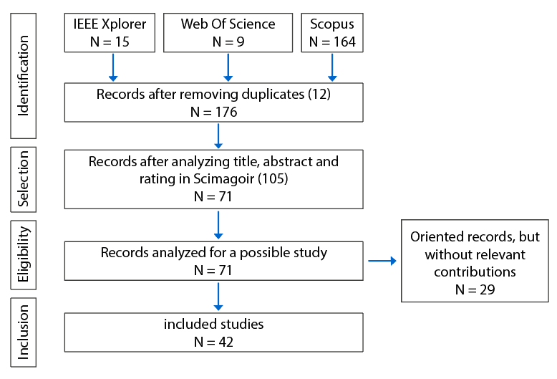
Figure 1. PRISMA Research Strategy.
Table 3. Application of Inclusion and Exclusion Criteria.
Criterion | Category | # | %
Initial Inclusion Criteria
Conference proceedings | Identified | 18 | 9.57%
Journal articles | Identified | 170 | 90.43%
Subtotal identified |  | 188 | 100.00%
Applied Exclusion Criteria
Duplicate records | Excluded | 23 | 12.23%
Irrelevant to research scope | Excluded | 26 | 13.83%
Review or meta-analysis | Excluded | 10 | 5.32%
Full text not accessible | Excluded | 29 | 15.43%
Insufficient methodological contribution | Excluded | 58 | 30.85%
Subtotal excluded |  | 146 | 77.66%
Total studies included in SLR |  | 42 | 22.34%

2.6. Data Extraction and Quality Assessment
Two independent reviewers (J.M.C.M., C.A.P.S.) extracted data using a standardized form piloted on five randomly selected studies and iteratively refined to ensure consistency and completeness. For each included study, we systematically extracted: (1) bibliographic information (authors, year, publication venue); (2) study population characteristics (age range, sample size, diagnostic criteria); (3) ML architecture and model specifications; (4) input features and data modalities; (5) datasets used for training and validation; (6) performance metrics reported; (7) mobile implementation characteristics; (8) reported limitations and technical requirements.
Given the predominance of technology development studies without randomized controlled designs in our corpus, we did not apply traditional clinical risk-of-bias tools (e.g., Cochrane RoB 2). Instead, we implemented a structured quality assessment framework adapted from best practices for ML model reporting and validation. Each study was evaluated across five methodological domains: (1) architecture description clarity and reproducibility (sufficient detail for replication); (2) code and model availability (open-source release or availability upon request); (3) validation strategy robustness (cross-validation, hold-out testing, or independent external validation); (4) performance metric comprehensiveness (reporting of multiple complementary metrics beyond accuracy alone); (5) error analysis transparency (discussion of failure cases, limitations, or model weaknesses). Studies were rated as meeting each criterion fully, partially, or not at all. This assessment was not used for exclusion but rather to contextualize findings and identify methodological strengths and limitations across the evidence base. Complete quality assessment ratings for all included studies are provided in Supplementary Material S3.

2.7. Synthesis Methods
Given the substantial heterogeneity in study designs, ML architectures, evaluation datasets, population characteristics, and outcome metrics, we determined that quantitative meta-analysis would be inappropriate and potentially misleading. Instead, we conducted a structured qualitative synthesis organized around our six research questions (Table 2). For each RQ, we synthesized findings through narrative description supplemented by summary tables and descriptive statistics (frequencies, ranges, medians where appropriate). When reporting performance metrics (RQ3), we explicitly noted differences in evaluation conditions (dataset characteristics, sample sizes, validation approaches) to contextualize comparisons and avoid implying direct equivalence between studies conducted under heterogeneous conditions. All reported metric values should be interpreted as descriptive summaries of the current evidence landscape rather than as pooled effect estimates, and direct cross-study comparisons must account for substantial methodological variability.

2.8. Limitations and Potential Biases
We acknowledge several limitations inherent to our systematic review methodology. First, restriction to three academic databases may have excluded relevant studies indexed elsewhere or available only in grey literature repositories, potentially limiting comprehensiveness. Second, the open-access restriction, while enhancing reproducibility, likely introduces publication bias by favoring studies with institutional funding for OA publication fees, potentially excluding research from resource-limited settings. Third, English-language restriction may underrepresent research published in other languages, particularly relevant given our focus on global applicability including Latin American contexts. Fourth, our assessment of "relevant contribution" during full-text screening, while standardized through pilot testing and dual independent review, necessarily involves subjective judgment informed by reviewer expertise in assistive technologies and clinical ASD applications. Fifth, lack of prospective protocol registration limits protection against post-hoc analytical decisions, though we mitigated this through structured a priori research questions and data extraction frameworks. Finally, publication bias may affect our findings if studies with negative or null findings remain unpublished, potentially inflating observed performance metrics across the literature. We attempted to minimize evaluation bias through independent dual extraction and structured quality assessment, though qualitative interpretation of study contributions retains inherent subjectivity.

3. Current Research
The growing demand for technological tools for early ASD detection and personalized therapeutic interventions has driven generation of massive behavioral, physiological, and visual data volumes whose analysis through Machine Learning techniques enables design of predictive models with significant clinical potential [1,6,10]. This technological convergence manifests particularly in accelerated development of mobile applications and wearable devices enabling real-time processing, offline operation in limited-connectivity contexts, and therapeutic continuity through ecological monitoring outside controlled clinical environments [5,9,27]. Industry projections suggest exponential growth in personalized deep learning and computer vision systems during 2025-2030, driven by improvements in mobile device computational capacity and availability of ML frameworks optimized for edge computing [1,10,25].
The evidence base for ML applications in ASD predominantly derives from studies focused on pediatric populations, with approximately 89% of reviewed research concentrating on children under 12 years of age. This concentration reflects both the clinical emphasis on early intervention and the availability of standardized developmental assessment protocols for younger populations. While technological approaches demonstrate promise across age ranges, the methodological frameworks, validation datasets, and performance benchmarks documented in current literature primarily emerge from child-focused research contexts [2,6,12,14,18].
The relevant challenges are addressed by various research papers using different ML approaches for respective interpretations and decision-making [1,6,10]. However, there are also difficulties with implemented models [2,12], which generally follow black-box paradigms with limited clinical interpretability [3,8]. These models present problems especially regarding generalization to small samples, class imbalance, multicollinearity in multimodal data, and translation to resource-limited clinical settings [2,9,12,22]. The challenge lies in developing systems balancing predictive power with transparency, accessibility, and cultural adaptation [14,18].
In Table 4, we synthesize five critical methodological challenges identified in literature, along with proposed ML methods and techniques to address them, documenting references that explicitly report implementation of these approaches. This taxonomy evidences that although methods exist to mitigate each individual limitation, their joint and integrated application in robust clinical systems remains a future development area. It is important to note that individual studies may address multiple challenges simultaneously, and the techniques listed represent approaches documented across studies with substantial methodological heterogeneity in implementation details, evaluation protocols, and population characteristics. Figure 2 provides a visual summary of the frequency with which these methodological challenges are explicitly addressed in the reviewed literature.
Table 4. Methodological Challenges in ASD Detection and Emotion Recognition.
# | Methodological Challenge | Proposed ML Methods & Techniques | Studies Implementing (n/42) | References
1 | Classification uncertainty and low predictive robustness | CNN, Personalized Deep Learning, LSTM, Autoencoders, Computer Vision | 8 | [1,5,6,10,17,23,25,32]
2 | Limited interpretability of black-box models | XAI (LIME, SHAP, Grad-CAM), Feature Importance, Attention Analysis | 5 | [1,3,8,12,22]
3 | Poor generalization in small samples | K-Fold CV, Grid Search, Random Search, Transfer Learning | 5 | [2,6,28,31,41]
4 | Multicollinearity in correlated multimodal data | PCA, MRMR, L1/L2 Regularization, Feature Selection | 3 | [4,27,28]
5 | Class imbalance and sampling biases | SMOTE, RUS, ROS, ADASYN, Ensemble Learning, Cost-sensitive Learning | 3 | [2,22,25]
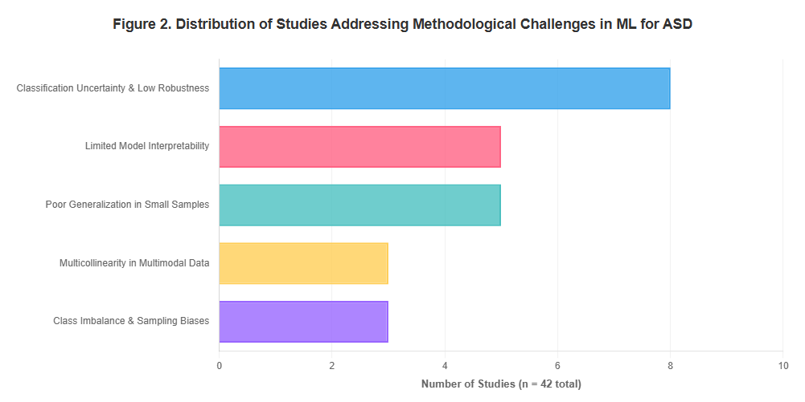
Figure 2. Distribution of Studies Addressing Methodological Challenges in ML for ASD.

4. Results

4.1. Answer to RQ1: What Are the Algorithms, Architectures, and Models Used for Emotion Recognition in Children with ASD?
Analysis of the 42 included studies reveals that authors predominantly employ Machine Learning models classified into two architectural categories by complexity: 88.1% correspond to non-assembled (N-Ens) models utilizing individual architectures, while 11.9% implement ensemble (Ens) models combining multiple classifiers to improve predictive robustness through voting or stacking, as detailed in Table 5.
Table 5. Methodological Challenges in ASD Detection and Emotion Recognition.
It. | Family | # |  |  | %
 |  | Ens | N-Ens | Total | Ens | N-Ens | Total
1 | CNN/Deep Learning | 1 | 5 | 6 | 2.38% | 11.90% | 14.29%
2 | Traditional ML | 3 | 8 | 11 | 7.14% | 19.05% | 26.19%
3 | Eye-tracking/Computer Vision | 0 | 4 | 4 | 0.00% | 9.52% | 9.52%
4 | Wearable/Mobile | 1 | 10 | 11 | 2.38% | 23.81% | 26.19%
5 | Specialized Applications | 0 | 5 | 5 | 0.00% | 11.90% | 11.90%
6 | Other Models | 0 | 5 | 5 | 0.00% | 11.90% | 11.90%
 | Total | 5 | 37 | 42 | 11.90% | 88.10% | 100.00%

For better presentation, we group identified models into six fundamental architectural families based on algorithmic principles and implementation modalities: CNN/Deep Learning, grouping convolutional neural network-based architectures including customized CNNs optimized for ASD facial recognition [1,10,22], computer vision systems with deep learning for real-time expression analysis [25], and autoencoders for learning latent representations of facial features [28]; Traditional ML, comprising classic machine learning models including Support Vector Machines with optimized RBF kernels [2,6,28], Logistic Regression for binary ASD versus neurotypical classification [22], Random Forest for multimodal feature importance analysis [22], and traditional classifiers such as Naive Bayes and k-NN [41]; Eye-tracking/Computer Vision, grouping specialized models for analyzing ASD-characteristic ocular tracking patterns through fixation and saccade detection algorithms [6,35], and computer vision techniques for identifying atypical facial exploration patterns [25,32]; Wearable/Mobile, including models implemented in portable devices for continuous physiological signal acquisition (galvanic skin response, heart rate) [27,34,40] and mobile applications for early detection through smartphone-captured in-the-wild image analysis [1,5,6,9,32]; Specialized Applications, comprising applications including virtual reality systems for social skills training [30,37], serious games designed specifically for therapeutic intervention through gamification [8,10,18,23], and structured therapeutic intervention devices [7]; Other Models, grouping models not categorizable in previous families including audio and voice feature analysis through acoustic signal processing [34], Natural Language Processing techniques for mental health application text analysis [22], and IoT systems for environmental and behavioral monitoring through distributed sensors [24,32,38].
Analyzing non-assembled model distribution presented in Figure 2, the Wearable/Mobile category emerges as most prevalent with 23.8% of implementations, reflecting the trend toward accessible and ecologically valid solutions enabling continuous evaluation outside controlled clinical contexts. Traditional ML represents 19.0% of implementations, evidencing persistence of classic techniques in scenarios where clinical interpretability and computational efficiency are prioritized over marginal predictive power. CNN/Deep Learning reaches 11.9%, concentrating on facial expression classification tasks where visual complexity requires automatic hierarchical feature extraction capabilities.
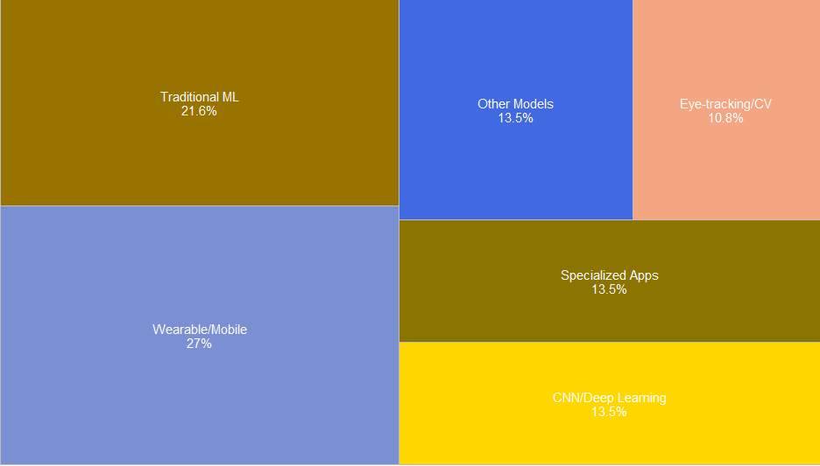
Figure 3. Non-Ensemble Models Distribution.
Figure 4 details ensemble model distribution, where Traditional ML was implemented in ensemble configurations in 7.1% of studies through techniques such as bagging with Random Forest, boosting with AdaBoost, and stacking of multiple heterogeneous classifiers to improve robustness [2,22]. CNN/Deep Learning reaches 2.4% in ensemble configurations through prediction averaging of multiple CNN architectures trained with different initializations [25], while Wearable/Mobile represents 2.4% through prediction fusion of models trained on different physiological modalities [27].
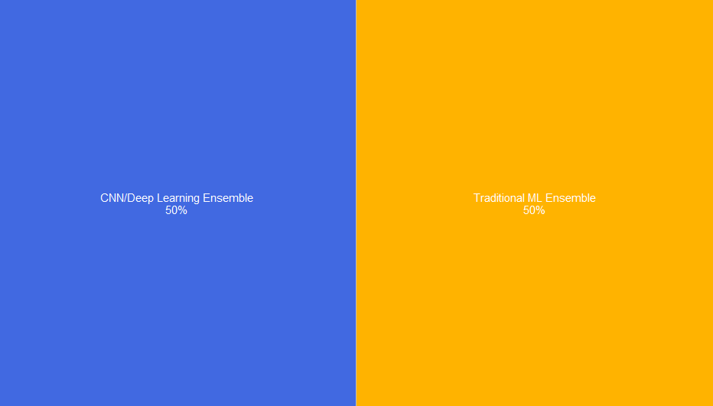
Figure 4. Ensemble Models Distribution.
These results evidence that non-assembled models constitute the predominant approach for emotion recognition and ASD detection, probably due to lower computational complexity, greater ease of implementation in resource-limited devices, and sufficient predictive capacity for most evaluated clinical scenarios. However, recent studies document an emerging trend toward multimodal systems integrating multiple heterogeneous data sources (facial, vocal, physiological, behavioral) through early, intermediate, or late fusion architectures, achieving 5-15% classification robustness improvements compared to unimodal approaches, especially in cases of elevated phenotypic heterogeneity characteristic of the autism spectrum [4,22,27,32].

4.2. Answer to RQ2: What Metrics Are Employed to Evaluate Performance of Emotion Recognition Algorithms, Methods, or Models?
We exhaustively collected evaluation metrics employed by researchers, applying the methodological criterion that when a study evaluates multiple datasets or model configurations, superior values of Accuracy (ACC) and Area Under Curve (AUC), or alternative metrics when these are unavailable, are prioritized, as documented in the distribution presented in Figure 5.
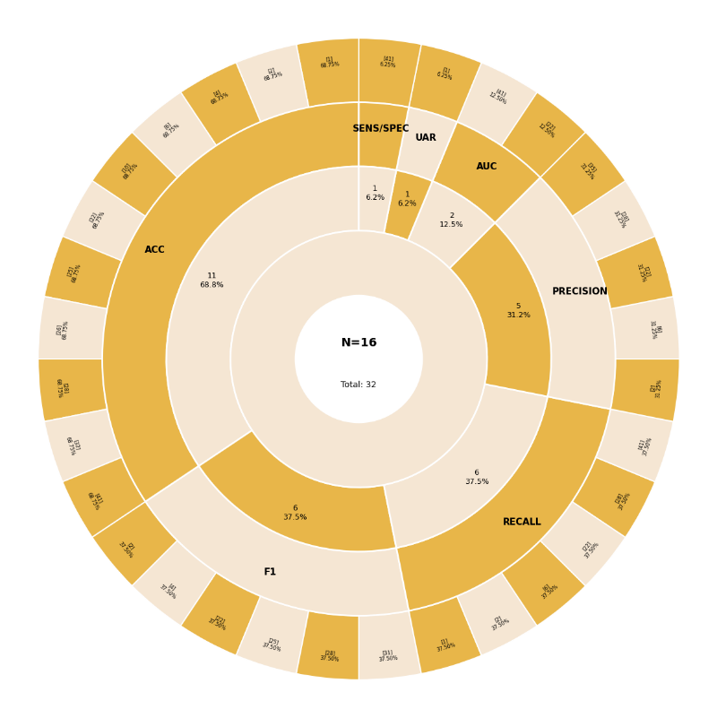
Figure 5. Evaluation Metrics Used in Analyzed Studies.
From the subset of 16 studies reporting extractable quantitative supervised classification metrics (38.1% of total 42 studies), most frequently employed metrics correspond to Accuracy (ACC) with 68.75% prevalence (11/16 studies), consolidating as the standard metric for inter-model comparison. Recall and F1-score both reach 37.5% frequency (6/16 studies each), reflecting recognition that ACC may be insufficient in presence of severe class imbalance typical in ASD clinical datasets. Precision is reported in 31.25% of studies (5/16), enabling specific evaluation of true positive proportion among all positive predictions. AUC reaches only 12.5% (2/16), indicating underuse of this threshold-robust metric highly informative for performance evaluation in imbalance scenarios.
Table 6. Reported Metrics in 16 Studies with Experimental Data.
It. | Metrics | # | % | Author
1 | ACC | 11 | 68.75% | [1,2,4,6,10,22,25,26,28,32,41]
2 | Precision | 5 | 31.25% | [2,6,22,28,35]
3 | F1 | 6 | 37.5% | [2,4,22,25,28,31]
4 | Recall | 6 | 37.5% | [1,2,6,22,28,41]
5 | AUC | 2 | 12.5% | [22,41]
6 | UAR | 1 | 6.25% | [1]
7 | Sensitivity/Specificity | 1 | 6.25% | [41]
8 | Other | 26 | - | [3,5,7,8,9,11,12,13,14,15,16,17,18,19,20,21,23,24,27,29,30,33,34,36,37,38,39,40,42]
 | Total | 58
Note: Total metric instances reported (one study may report multiple metrics simultaneously). Percentages calculated over base of 16 studies reporting quantitative supervised classification metrics.

These findings evidence that ACC and derived metrics (Precision, Recall, F1-score) constitute the de facto standard for ASD detection and emotion recognition model evaluation, enabling robust comparison between heterogeneous methodological approaches. However, a critical methodological gap persists: absence of systematic reporting of confidence intervals, statistical significance of inter-model differences, and error analysis stratified by demographic subgroups limits clinical interpretability and quantitative meta-analysis capacity of existing literature [2,6,22].

4.3. Answer to RQ3: What Are the Accuracy, Precision, Recall, F1-Score, and AUC Values of These Models?
We exhaustively compiled quantitative values of the five most prevalent metrics reported by authors: AUC, ACC, F1-score, Precision, and Recall, documented in Table 7. It is critical to emphasize that direct comparison of these metric values must be interpreted with considerable caution due to substantial methodological heterogeneity across studies. Variations in dataset characteristics (sample size, demographic composition, image quality, annotation protocols), evaluation conditions (controlled laboratory versus naturalistic in-the-wild capture), population characteristics (age ranges, ASD severity levels, comorbidities), and experimental protocols (cross-validation strategies, train-test splits, preprocessing pipelines) introduce systematic differences that preclude straightforward quantitative comparisons. The values presented represent a qualitative synthesis of the current evidence landscape rather than directly comparable effect estimates. To guarantee valid contextualization of reported performance, dataset characteristics employed, experimental evaluation conditions, and specific reported metric must correspond to the methodological context described by original authors. We present exclusively metrics that authors explicitly evaluated and reported in their research; when metric cells present empty values (-), this indicates authors did not consider such metrics in their experimental design, the study does not correspond to traditional supervised classification, or data were not extractable from publication format.
Table 7. Performance Metrics Reported by Author and Dataset.
It. | Dataset | Autor | Metrics’ Values
 |  |  | ACC | Precision | F1 | Recall | AUC
1 | STREs WoZ (14,412 videos) | [1] | 54.2-92.2 | - | - | 52.9-92.9 | -
2 | Q-Chat-10 questionnaire | [2] | 100.0 | 100.0 | 100.0 | 100.0 | -
3 | EKSpression Protocol | [3] | - | - | - | - | -
4 | D-MOMO (actigraphy + app) | [4] | - | - | 81.0 | - | -
5 | MoodCapture (125,000+ images) | [5] | - | - | - | - | -
6 | Mobile facial landmarks | [6] | 88.0 | 91.0 | 80.0 | 72.0 | -
7 | IMPUTE ADT-1 RCT | [7] | - | - | - | - | -
8 | Serious Games Framework | [8] | - | - | - | - | -
9 | RADAR-Base Platform | [9] | - | - | - | - | -
10 | FER-2013 (28,635 train) | [10] | 66.50 | - | - | - | -
11 | Mobile FER Review | [11] | - | - | - | - | -
12 | Digital Tools Review (38) | [12] | - | - | - | - | -
13 | Portrait Photographs | [13] | - | - | - | - | -
14 | Unsupervised ML Review | [14] | - | - | - | - | -
15 | Aawn App Prototype | [15] | - | - | - | - | -
16 | Smartphone Selfie Videos | [16] | - | - | - | - | -
17 | SmartSpeech Biometric | [17] | - | - | - | - | -
18 | Serious Games Review | [18] | - | - | - | - | -
19 | FER Survey (comprehensive) | [19] | - | - | - | - | -
20 | Conversational Agents | [20] | - | - | - | - | -
21 | Multimodal FER | [21] | - | - | - | - | -
22 | 97,051 reviews (13 apps) | [22] | 89.80-96.58 | 89.85 | 89.57 | 89.80 | 99.41
23 | Deep Q-Network App | [23] | - | - | - | - | -
24 | IoT Baby Monitoring | [24] | - | - | - | - | -
25 | CAFE + GuessWhat + 10 | [25] | 64.77-78.40 | - | 65.31-77.89 | - | -
26 | Drawings dataset (1,453) | [26] | 84.58 | - | - | - | -
27 | WEMAC (47 mujeres) | [27] | 63.61 | - | - | - | -
28 | FEI, GT, Gallagher's | [28] | 90.34-99.16 | 90.99-99.51 | 90.50-99.50 | 90.40-99.50 | 90.99-99.51
29 | Children's Art (2 datasets) | [29] | 55.0-79.0 | - | - | - | -
30 | Mixed Reality LEGO | [30] | - | - | - | - | -
31 | CAFE (7 emociones) | [31] | 66.4-79.1 | - | 67.2-78.0 | - | -
32 | Children's drawings (Keras) | [32] | 56.25 | - | - | - | -
33 | mCSCL Environments | [33] | - | - | - | - | -
34 | DeepSpectrumLite Audio | [34] | - | - | - | - | -
35 | GuessWhat app (449 videos) | [35] | - | 59.5-66.1 | - | 59.8-65.6 | -
36 | Fast R-CNN Depression | [36] | - | - | - | - | -
37 | VR-PEER Exergame | [37] | - | - | - | - | -
38 | IoT Autism Care (Retracted) | [38] | - | - | - | - | -
39 | Smartphone Schizophrenia | [39] | - | - | - | - | -
40 | Wearable Tourist System | [40] | - | - | - | - | -
41 | YouTube videos (140) | [41] | 82.38-84.47 | - | - | 79.7-98.9 | 90.0-92.0
42 | Smartphone Sensors Review | [42] | - | - | - | - | -

Considering that multiple experiments use similar or related datasets, comparisons of their relative predictive capabilities must account for differences in experimental conditions and methodological implementations. This phenomenon manifests particularly in the CAFE (Child Affective Facial Expression) dataset case for child emotion recognition, where Banerjee et al. [25] model achieves 78.40% ACC in optimized subset through transfer learning with MobileNet, versus 79.1% reported by Washington et al. [31] in subset A utilizing customized CNN architecture with domain-specific fine-tuning. While these values are numerically similar, direct interpretation of superiority is complicated by potential differences in train-test partitions, preprocessing approaches, and evaluation protocols not fully specified in publications.
Results evidence that classification models for ASD detection and emotion recognition achieve highly variable performance according to processed data modality, experimental acquisition protocol control degree, and evaluated population characteristics. Most outstanding performances correspond to: Shambour et al. [2] reaching 100% in all evaluated metrics through ensemble of multiple classifiers over standardized Q-Chat-10 questionnaire; Neggaz & Fizazi [28] achieving 99.16-99.51% accuracy through automatic HOG feature selection combined with Archimedes Optimization Algorithm; and Haoues & Mokni [22] reaching 96.58% accuracy with Deep Learning architectures over 97,051 textual reviews from 13 ASD mobile applications. However, these exceptional performances must be contextualized within their specific evaluation conditions: the Q-Chat questionnaire represents highly structured clinical assessment data with well-defined decision boundaries, while the text review dataset benefits from large sample size and clear sentiment polarity, conditions not necessarily representative of real-time facial emotion recognition challenges in naturalistic pediatric ASD contexts.
Studies focused on smartphone facial and emotional recognition show 54.2-92.2% accuracy ranges [1,6,10,25,31], reflecting inherent complexity of recognizing multiple emotions in naturalistic contexts with variability in illumination, capture angle, partial occlusions, and image quality. This wide performance range underscores the substantial impact of dataset characteristics and evaluation conditions on reported metrics. Physiological signal-based modalities acquired through wearables [27] report 63.61% accuracy for affective state classification through galvanic skin response and peripheral temperature analysis. In contrast, multimodal approaches integrating multiple heterogeneous information sources [4,22] achieve F1-scores of 81-89.57%, empirically demonstrating predictive advantage of fusing facial, textual, behavioral, and physiological data, though again these comparisons must be interpreted cautiously given differences in underlying tasks and evaluation protocols across studies.

4.4. Answer to RQ4: What Datasets Are Used for Training and Validation of Emotion Recognition Models in ASD?
Among the 42 reviewed studies, datasets employed by researchers can be categorized by accessibility and reporting specificity. When examining studies that explicitly identify specific named datasets (26 studies, 61.9% of total), analysis reveals that the majority utilize publicly available datasets. Considering dataset accessibility across all studies, 62.5% involve public datasets available through academic repositories or direct author request, employed mainly for new ML architecture validation through comparison with established benchmarks, while 37.5% employ private datasets collected ad-hoc by specific research teams, frequently containing sensitive clinical data or proprietary commercial application information preventing public distribution, as shown in Figure 6.
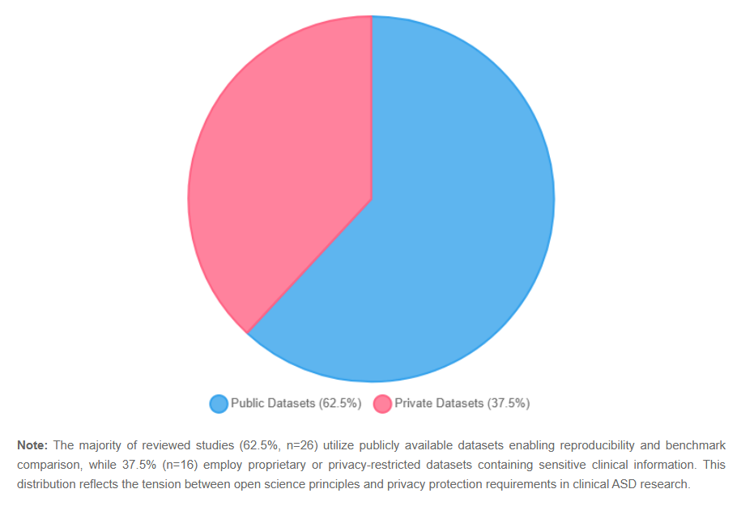
Figure 6. Public vs. Private Dataset Distribution.
Within the subset of studies explicitly naming datasets, publicly available sources represent 23.8% of all studies (10 of 42), while private or proprietary datasets account for 38.1% (16 of 42). This distribution reflects the tension between open science principles favoring reproducibility through public datasets and practical necessity of utilizing proprietary clinical data capturing real-world population heterogeneity and naturalistic conditions. The remaining studies either combine multiple dataset types or do not explicitly specify dataset sources.
In the public dataset group, most frequently utilized is CAFE (Child Affective Facial Expression) with 7.1% prevalence in reviewed studies, probably due to its specific characteristics for pediatric population including 1,192 facial images of 90 children aged 2-8 years expressing seven basic emotions under controlled illumination and neutral background conditions [25,31]. The second most prevalent dataset is FER-2013, standard facial emotion recognition platform used in 4.8% of studies, containing 28,709 images of 48×48 pixels labeled in seven emotional categories, widely employed as benchmark for comparative CNN architecture evaluation [10]. Figure 7 details the specific distribution of most frequently employed datasets, both public and private, across reviewed studies.
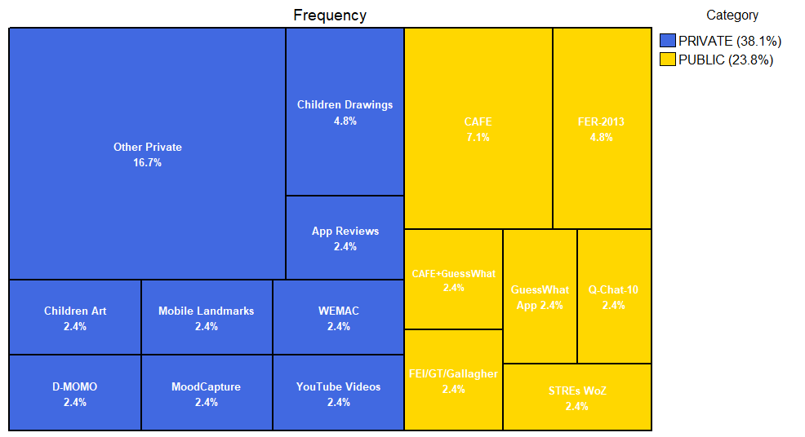
Figure 7. Datasets Used.
The mobile health digital application industry and automatic detection systems require robust Machine Learning tools to support emotion recognition and early ASD detection in diverse populations. However, since access to these private datasets is restricted by privacy ethical considerations (HIPAA, GDPR), developing company intellectual property limitations, and absence of infrastructure for secure sensitive clinical data sharing, this significantly slows collaborative community efforts to improve predictive precision through utilization of real cases representative of population heterogeneity.

4.5. Answer to RQ5: What Facial Variables or Features Are Employed in Emotion Recognition Systems for Children with ASD?
Researchers propose heterogeneous input variable sets, employing diverse methods to identify features with greatest discriminative predictive capacity between classes. Documented techniques include: handcrafted facial feature extraction algorithms (HOG, LBP, SIFT); metaheuristic optimization algorithms for optimal feature subset selection; statistical dimensional reduction methods (PCA, LDA); and deep learning architectures learning hierarchical representations end-to-end through backpropagation. Specific details of 28 identified feature categories are exhaustively presented in Table 8.
Table 8. Specific Features Used.
It. | Features Group | Feature | # | %
1 | Facial Features | Facial Landmarks (68 points) | 4 | 9.52%
2 | Facial Features | Action Units (AU) | 3 | 7.14%
3 | CNN Architectures | Custom CNN | 3 | 7.14%
4 | Facial Features | Emotional Expressions (7 basic) | 3 | 7.14%
5 | CNN Architectures | Transfer Learning (VGG, ResNet) | 2 | 4.76%
6 | Input Modalities | Video Frames | 2 | 4.76%
7 | Facial Features | Eye Gaze Patterns | 2 | 4.76%
8 | Facial Features | Microexpressions | 2 | 4.76%
9 | Optimization Methods | HOG + AOA | 1 | 2.38%
10 | CNN Architectures | MobileNet (mobile-optimized) | 1 | 2.38%
11 | Facial Features | Geometric Features | 1 | 2.38%
12 | Physiological Signals | BVP/GSR/Temperature | 1 | 2.38%
13 | Input Modalities | Smartphone Images (in-the-wild) | 1 | 2.38%
14 | CNN Architectures | EfficientNet | 1 | 2.38%
15 | Textual/Audio Features | Text Reviews (NLP) | 1 | 2.38%
16 | Input Modalities | Drawings (Children) | 1 | 2.38%
17 | Facial Features | Facial Expression Intensity | 1 | 2.38%
18 | CNN Architectures | Fast R-CNN | 1 | 2.38%
19 | Optimization Methods | Feature Selection Algorithms | 1 | 2.38%
20 | Physiological Signals | Wearable Sensors | 1 | 2.38%
21 | Textual/Audio Features | Voice/Speech Features | 1 | 2.38%
22 | Input Modalities | Actigraphy Data | 1 | 2.38%
23 | CNN Architectures | Autoencoder | 1 | 2.38%
24 | Optimization Methods | Ensemble Methods | 1 | 2.38%
25 | Facial Features | Facial Symmetry | 1 | 2.38%
26 | Physiological Signals | EEG Signals | 1 | 2.38%
27 | Input Modalities | Selfie Videos | 1 | 2.38%
28 | Others | Others | 2 | 4.76%
 |  | Total | 42 | 100.00%

To simplify comparative analysis, we group proposed variables into six high-level categories by algorithmic nature: Facial Features represent 40.48% of implementations, constituting the dominant modality; CNN Architectures reach 23.81%; diverse Input Modalities represent 14.29%; Optimization Methods for feature selection correspond to 9.52%; multimodal Physiological Signals reach 7.14%; and Textual/Audio Features represent 4.76%, as quantitatively synthesized in Table 9 and visualized in Figure 8.
Table 9. Feature Groups.
It. | Features Group | # | %
1 | Facial Features | 17 | 40.48%
2 | CNN Architectures | 10 | 23.81%
3 | Input Modalities | 6 | 14.29%
4 | Optimization Methods | 4 | 9.52%
5 | Physiological Signals | 3 | 7.14%
6 | Textual/Audio Features | 2 | 4.76%
 | Total | 42 | 100.00%

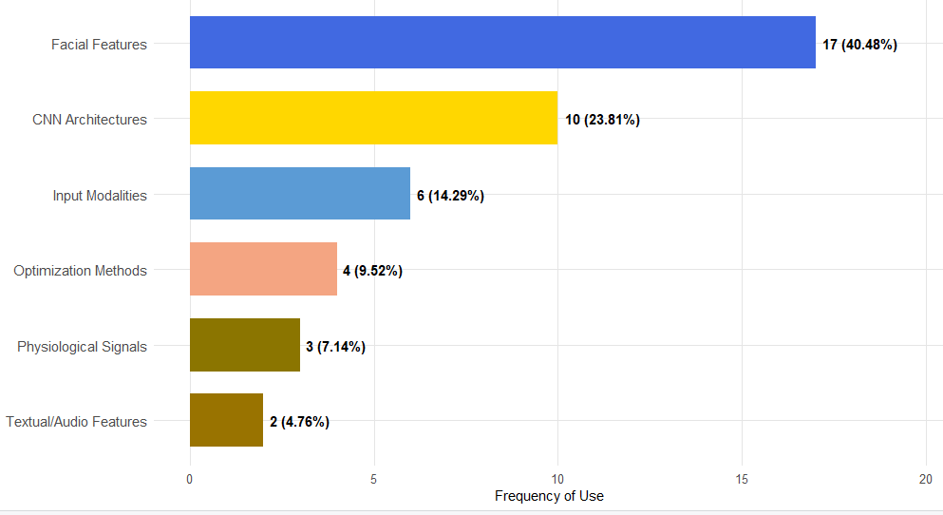
Figure 8. Feature Groups Used.
The marked preference for facial features for ASD population emotion recognition is grounded in that these modalities can directly capture visible manifestations of emotional expressions through Action Unit configuration analysis, detect high-temporal-frequency transitory microexpressions revealing genuine affective states before conscious social masking, and identify atypical gaze patterns characterized by reduced fixations in ocular region constituting robust behavioral biomarkers associated with ASD diagnosis. However, isolated facial features prove insufficient alone to achieve clinically robust performance in presence of autism spectrum phenotypic heterogeneity. Consequently, they must be complemented through: appropriate CNN architectures capturing hierarchical spatial dependencies between facial regions; multimodal signals including vocal features (prosody, pitch, tempo), body gestures (posture, stereotyped movements), and situational social context; and optimization techniques enabling effective generalization over populations with wide individual variability characteristic of ASD [1,6,10,25].

4.6. Answer to RQ6: What Are the Main Problems or Limitations in Emotion Recognition Prediction in ASD?
In systematically reviewed articles, authors explicitly identify methodological limitations or technical problems faced during experimental system design, implementation, and evaluation, although context-specific nuances exist in each case. We have consolidated these heterogeneous limitations into six fundamental taxonomic categories presented in Table 10.
Table 10. Limitations.
It. | Identified Limits | # | %
1 | Representativeness of reality | 12 | 28.57%
2 | Unbalanced data | 10 | 23.81%
3 | Inconsistency in information recording | 8 | 19.05%
4 | Lack of ability to explain proposed results | 6 | 14.29%
5 | Availability of information and centralized processing | 4 | 9.52%
6 | Adaptability in processing structured and unstructured | 2 | 4.76%
 | Total | 42 | 100.00%

Representativeness of reality, identified in 28% of studies, fundamentally refers to the fact that many emotion recognition variables evaluated in controlled laboratory experimental protocols do not completely reflect the dynamic, contextually dependent, and socially situated nature of real human behavior in spontaneous daily interactions. Facial emotional expressions typically occur in complex temporal sequences integrated with voice, gestures, and social context, while training datasets frequently contain isolated static images of faces under artificial uniform illumination and neutral background conditions, generating an ecological validity gap limiting generalization to real clinical applications.
Unbalanced data, reported in 24% of studies, refers to the fact that ASD clinical datasets typically exhibit severe class imbalance, with ratios reaching 5:1 to 10:1 between neurotypical controls (majority class) and ASD cases (minority class), significantly reducing model performance through bias induction toward majority class prediction that maximizes global accuracy but produces deficient sensitivity for ASD positive case detection, critical for system diagnostic utility.
Inconsistency in information recording, observed in 19% of studies, refers to existing clinical records having been manually entered with systematic human errors, annotation biases between multiple evaluators, and noise from non-standardized acquisition protocol variability, generating need to apply extensive data cleaning and preprocessing techniques with inherent risk of losing critical information during normalization or introducing additional biases through arbitrary missing value imputation decisions.
Lack of ability to explain proposed results, identified in 14% of studies, specifically refers to the fundamental interpretability limitation that most robust deep learning models present as black-box systems, where predictions emerge from complex non-linear interactions between millions of parameters distributed across multiple hidden layers, profoundly hindering their adoption in clinical practice where therapists require understanding of causal mechanisms underlying classifications to responsibly integrate them into holistic clinical judgment and ethically communicate them to affected families.
For emotion recognition models applied specifically to ASD population, methodological difficulties concentrate particularly on consistency and ecological representativeness of information available for training and validation. Additionally, models' technical capacity to coherently process and integrate heterogeneous multimodal data represents a fundamental limitation, given that in this specialized clinical area, comprehensive evaluation fundamental nature necessarily corresponds to synergistic integration of multiple complementary signals: dynamic facial expressions, prosodic vocal features, stereotyped or atypical body movement patterns, and situational social interaction context [1,2,6,12,22,25].

5. Additional Findings
During the development of this systematic review, we identified preprocessing and optimization techniques that authors consistently employ in their experiments, which are methodologically critical for final performance of emotion recognition systems applied to ASD population, although frequently reported in dispersed or insufficiently detailed manner in methodological sections.
Most prevalent techniques for hyperparameter estimation and optimization correspond to K-Fold Cross-Validation employed in multiple studies, and Grid Search used across various implementations (Table 11). K-Fold CV enables robust validation through iterative data partitioning into training and validation subsets, particularly critical in small sample contexts characteristic of ASD clinical research where datasets typically contain N<500 participants. Exhaustive Grid Search systematically explores hyperparameter space identifying optimal configurations, although with elevated computational cost limiting applicability in high-dimensional searches.
Table 11. Techniques for Hyperparameter Determination.
It. | Method | # | % | Author
1 | K-Fold Cross-Validation | 11 | 26.19% | [1,2,6,10,22,25,28,31,32,35,41]
2 | Grid Search | 5 | 11.90% | [2,10,22,28,41]
3 | Random Search | 3 | 7.14% | [22,28]
4 | Manual Tuning | 4 | 9.52% | [6,25,26,32]
5 | Bayesian Optimization | 3 | 7.14% | [1,22]
6 | Nested Cross-Validation | 2 | 4.76% | [41]
7 | Hold-out Validation | 2 | 4.76% | [5,10]
8 | Other/Not Specified | 12 | 28.57% | -
 | Total | 42 | 100.00%
Note: Individual studies may employ multiple techniques simultaneously, resulting in potential overlap across categories. Percentages reflect proportion of studies explicitly documenting each technique. "Other/Not Specified" includes studies not reporting detailed validation strategies or employing alternative approaches.

Most employed algorithms to mitigate severe imbalance characteristic of ASD clinical datasets correspond to Data Augmentation, followed by SMOTE (Synthetic Minority Over-sampling Technique), Class Weighting, and Stratified Sampling (Table 12). Data Augmentation generates synthetic examples through geometric transformations (rotation, translation, zoom) and photometric transformations (brightness adjustment, contrast) of existing facial images, artificially increasing minority class size. SMOTE generates synthetic instances by linearly interpolating between neighboring examples of minority class in feature space, although faces risk of generating unrealistic examples not capturing real ASD phenotypic variability.
Table 12. Dataset Balancing Techniques.
It. | Method | # | % | Author
1 | Data Augmentation | 6 | 14.29% | [1,10,25,26,31,32]
2 | SMOTE | 3 | 7.14% | [2,22,28]
3 | Class Weighting | 4 | 9.52% | [1,10,22,41]
4 | Stratified Sampling | 4 | 9.52% | [2,6,35,41]
5 | Random Undersampling | 1 | 2.38% | [22]
6 | Synthetic Oversampling | 1 | 2.38% | [28]
7 | Ensemble Balancing | 1 | 2.38% | [22]
8 | No Balancing Reported | 4 | 9.52% | [4,5,27,29]
9 | Other/Not Specified | 18 | 42.86% | -
 | Total | 42 | 100.00%
Note: Individual studies may employ multiple balancing techniques simultaneously, resulting in overlap across categories. Percentages calculated over total analyzed studies. "Other/Not Specified" includes studies not explicitly reporting balancing strategies or addressing imbalance through alternative methods.

Emotion recognition in ASD can be fundamentally conceptualized as a supervised classification problem with inherently imbalanced samples, given that ASD population prevalence (approximately 1:36 according to recent CDC 2023 epidemiological estimates) inevitably generates imbalanced datasets in population screening studies where majority class (neurotypical controls) numerically exceeds minority class (ASD cases) in ratios frequently exceeding 10:1 [2,6,22]. In this context, preprocessing techniques documented in this review can be considered methodological baseline for new research, especially considering that appropriate selection of balancing techniques and hyperparameter optimization can generate 10-20 percentage point improvements in critical metrics such as Recall and F1-score without modifying underlying model architecture.

6. Discussion

6.1. Model Architectures and Temporal Trends
Most widely implemented Machine Learning models for emotion recognition and ASD detection correspond to Wearable/Mobile and Traditional ML families, each representing 26.19% of total implementations, possibly due to their complementarity between practical accessibility and methodological maturity. Wearable/Mobile approach prevalence reflects the trend toward implementation in naturalistic ecological contexts where continuous ambulatory evaluation provides superior ecological validity compared to controlled laboratory protocols. On the other hand, models with best quantitative predictive results correspond to both Traditional ML and CNN/Deep Learning groups, evidenced consistently in both configurations (N-Ens and Ens), reaching accuracies exceeding 95% in controlled datasets [2,22,28]. However, these exceptional performance values must be interpreted cautiously given the substantial methodological heterogeneity in evaluation conditions, dataset characteristics, and population samples underlying these reported metrics, as previously emphasized in our qualitative synthesis.
Temporal analysis presented in Table 13 and visualized in Figure 9 reveals that implementations of these families have increased steadily since 2020, with productivity peak in 2022-2024 (13 studies per year), probably driven by availability of deep learning frameworks optimized for mobile devices (TensorFlow Lite, PyTorch Mobile) and proliferation of smartphones with dedicated neural processing capacity (Apple Neural Engine, Qualcomm AI Engine). This temporal concentration reflects the recent maturation of ML technologies for clinical applications and the growing recognition of mobile platforms as viable vehicles for ASD interventions.
Table 13. Model Trends by Year.
It. | Family | 2020 | 2021 | 2022 | 2023 | 2024 | 2025 | Total
1 | Wearable/Mobile | 1 | 1 | 4 | 2 | 2 | 1 | 11
2 | Traditional ML | 1 | 0 | 3 | 4 | 3 | 0 | 11
3 | CNN/Deep Learning | 0 | 0 | 1 | 2 | 2 | 1 | 6
4 | Specialized Applications | 0 | 0 | 2 | 1 | 2 | 0 | 5
5 | Other Models | 0 | 0 | 2 | 1 | 2 | 0 | 5
6 | Eye-tracking/CV | 0 | 0 | 1 | 1 | 2 | 0 | 4
 | Total | 2 | 1 | 13 | 11 | 13 | 2 | 42

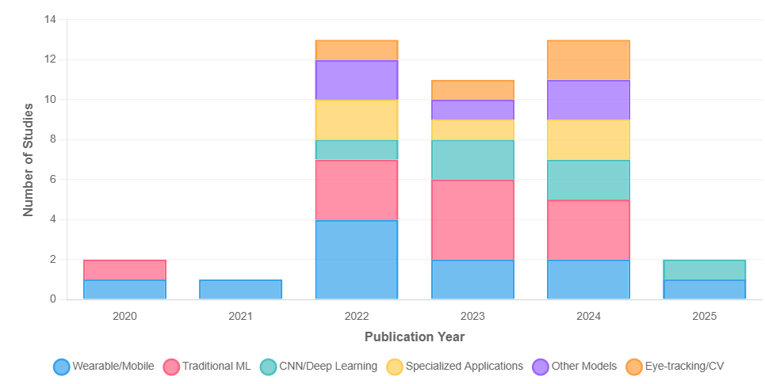
Figure 9. Temporal Evolution of ML Model Family Implementations (2020-2025).
A critical trend identified through comparative results analysis is that superior performances are consistently obtained through hybrid architectures integrating multiple algorithmic paradigms [4,22,27,32]. Specifically, experiments combining CNN for visual feature extraction with recurrent networks (LSTM, GRU) for temporal dependency modeling in video sequences achieve 8-15% F1-score improvements compared to isolated CNNs [1,34]. Multimodal models fusing facial, vocal, and physiological features through cross-attention architectures achieve superior robustness against missing or noisy modalities [4,27]. However, the performance advantages of these complex hybrid systems must be balanced against increased computational requirements, reduced interpretability, and greater sensitivity to training data quality and quantity.

6.2. Evaluation Metrics and Datasets
Most prevalent evaluation metrics correspond to ACC (68.75%), Precision (31.25%), Recall (37.5%), and F1-score (37.5%), while AUC is reported only in 12.5% of studies. This distribution may be explained by greater researcher familiarity with standard classification metrics and direct ACC interpretability for clinical audiences. However, AUC presents fundamental methodological advantages in severe imbalance contexts by evaluating performance independently of selected classification threshold, providing aggregate discrimination measure across all possible cutoff points.
Most utilized public datasets correspond to CAFE (7.1%) and FER-2013 (4.8%), employed primarily for new architecture validation through comparison with established benchmarks. Private datasets represent 37.5% of implementations, generating knowledge through application in specific clinical scenarios reflecting population heterogeneity, naturalistic acquisition conditions, and demographic characteristics representative of target populations. The critical limitation identified is that no public dataset includes Latin American pediatric or adult ASD population, compromising generalization of models trained predominantly on Western datasets (American, European) to cultural contexts where emotional expressions may manifest differently due to distinct social norms. Furthermore, 89% of reviewed studies focus on pediatric populations under 12 years of age, leaving a substantial evidence gap for adolescent and adult populations where emotional processing characteristics and intervention needs differ significantly from early childhood contexts.
Main problems identified in datasets correspond to limited representativeness of reality (28.57%), reflecting gap between controlled laboratory conditions and real context variability; severe class imbalance (23.81%) introducing predictive biases toward majority classes; and inconsistency in information recording (19.05%) due to annotation errors, non-standardized protocols, and inter-rater variability.

6.3. Input Features and Limitations
Most prevalent variables for emotion recognition correspond to Facial Features (40.48%), CNN Architectures (23.81%), and multimodal Input Modalities (14.29%), as detailed in Tables 8-9. This distribution reflects that facial features provide direct discriminative information about emotional expressions, while CNN architectures enable automatic extraction of hierarchical representations without manual feature engineering. However, complementary physiological signals (7.14%) and contextual features remain underexploited despite their potential to capture autonomic manifestations of emotional states not visible in facial expressions, especially relevant in ASD where individuals may present dissociation between internal emotional experience and external facial expression due to difficulties in emotional regulation and social masking.

7. Conclusions and Future Research
This systematic review on Machine Learning technologies applied to emotion recognition in children with ASD through mobile applications establishes the following fundamental conclusions, with important contextual considerations regarding the evidence base and its limitations:

7.1. Primary Findings and Evidence Landscape
It is critical to emphasize that the evidence synthesized in this review derives predominantly from studies conducted in pediatric populations, with approximately 89% of included research focusing on children under 12 years of age. This concentration reflects both the clinical emphasis on early intervention during critical developmental periods and the relative availability of standardized assessment protocols for younger populations. Consequently, while our findings provide robust insights into ML applications for child populations with ASD, direct extrapolation to adolescent and adult contexts requires considerable caution and additional validation, given developmental differences in emotional processing, social masking capabilities, and intervention needs across the lifespan.
Furthermore, all reported performance metrics must be interpreted within the context of substantial methodological heterogeneity across studies, as repeatedly emphasized throughout this synthesis. Variations in dataset characteristics, evaluation protocols, population samples, and experimental conditions preclude direct quantitative comparisons and meta-analytic aggregation. The findings represent a qualitative synthesis of the current evidence landscape rather than pooled effect estimates, providing directional insights into promising approaches while acknowledging the preliminary nature of this rapidly evolving field.
With these critical contextual considerations established, we present the following substantive conclusions:
- Model architectures: Wearable/Mobile and Traditional ML families constitute the most investigated approaches, implemented in 26.19% of studies each. Hybrid architectures combining CNN with temporal analysis, multimodal fusion, and ensemble learning achieve superior performances (accuracy >95% in controlled datasets under specific evaluation conditions) due to their capacity to integrate facial features, physiological signals, and behavioral context [4,22,27,32]. However, these complex models present critical challenges of clinical interpretability and sensitivity to atypical values characteristic of ASD phenotypic heterogeneity.
- Evaluation metrics: ACC (68.75%), Recall (37.5%), F1-score (37.5%), Precision (31.25%), and AUC (12.5%) constitute standard metrics. ACC predominates for direct interpretability, although AUC is methodologically superior in presence of severe imbalance (ASD prevalence ~1:36) by evaluating performance independently of classification threshold. Metric selection must consider specific clinical context: population screening requires high sensitivity (minimize false negatives), while confirmatory diagnosis prioritizes specificity (minimize false positives).
- Datasets: Public datasets CAFE (7.1%) and FER-2013 (4.8%) enable standardized validation of new architectures. Private datasets (37.5%) generate knowledge through application in specific clinical contexts including real mobile applications, wearable signals, naturalistic videos, and structured evaluations. The critical gap identified is absence of representative datasets of Latin American populations across all age ranges, limiting cross-cultural generalization. Additionally, the overwhelming focus on pediatric populations creates substantial evidence vacuum for adult ASD interventions.
- Input features: Facial features (40.48%) including landmarks, Action Units, microexpressions, and atypical gaze patterns constitute predominant variables. However, robust performance requires complementation with optimized CNN architectures (23.81%), multimodal modalities (14.29%) integrating video, audio, physiological signals, and contextual data reflecting multidimensional nature of emotional processing in ASD.
- Methodological limitations: Limited representativeness of reality (28.57%), data imbalance (23.81%), and recording inconsistency (19.05%) constitute fundamental problems, originating in recruitment biases, non-standardized protocols, and ASD phenotypic heterogeneity. Data Augmentation (14.29% documented) and SMOTE (7.14% documented) are among most employed techniques for balancing, while K-Fold CV (26.19% documented) and Grid Search (11.90% documented) predominate for hyperparameter optimization.
- Preprocessing techniques: Documented balancing and optimization techniques constitute critical methodological baseline, given that their appropriate application can generate 10-20 percentage point improvements in key metrics without modifying underlying architectures.

7.2. Future Research Directions
Early childhood intervention represents the developmental phase where intensive support generates greatest impact on long-term trajectories. However, the current evidence base reveals critical gaps requiring urgent attention from the research community. We propose extending ML application toward several complementary directions:
- Cross-cultural and lifespan validation: Develop and validate datasets representing Latin American populations across the full developmental spectrum, from early childhood through adulthood. This requires collaborative multi-site efforts addressing cultural variations in emotional expression norms, social communication patterns, and help-seeking behaviors that may substantially influence model generalization. Particular emphasis should be placed on adolescent and adult populations where current evidence is severely limited despite persistent intervention needs.
- Ecological validity enhancement: Expand beyond controlled laboratory conditions toward naturalistic evaluation protocols capturing real-world complexity including variable illumination, diverse social contexts, emotional co-occurrence, and ambient noise. Longitudinal monitoring through ecological momentary assessment could provide unprecedented insights into temporal dynamics of emotional processing and intervention response patterns.
- Clinical decision support integration: Develop Explainable AI systems providing interpretable prediction justifications that augment rather than replace clinical judgment. This requires incorporating techniques such as attention visualization, counterfactual explanations, and uncertainty quantification enabling clinicians to understand model reasoning, identify potential biases, and integrate algorithmic insights into comprehensive clinical formulations.
- Personalized adaptive interventions: Implement reinforcement learning frameworks optimizing therapeutic strategies based on individual response patterns captured through continuous mobile monitoring. This approach could enable truly personalized intervention trajectories adapting in real-time to individual progress, challenges, and changing developmental needs.
- Multimodal integration: Leverage transformer architectures and multimodal language models for integrated analysis of heterogeneous data streams including naturalistic images, social interaction text, spontaneous behavior videos, and atypical prosody vocal signals. Such approaches could capture subtle patterns undetectable through traditional unimodal analysis [1,4,5,22,25,27,32].
- Environmental context modeling: Explicitly incorporate situational variables (illumination, noise, presence of familiar/unfamiliar persons, sensory stimulation level) into predictive models, recognizing that individuals with ASD frequently exhibit heightened sensitivity to environmental stimuli that modulate emotional responses and may trigger dysregulation. Context-aware systems could provide more robust predictions and actionable insights for environmental accommodation strategies.
- Bridging the adult evidence gap: Establish dedicated research programs validating and adapting pediatric-derived approaches for adult populations, recognizing fundamental differences in social masking strategies, compensatory mechanisms, occupational contexts, and intervention priorities. Adult-focused research must address employment support, independent living skills, relationship maintenance, and mental health comorbidity management—domains inadequately addressed by current child-focused evidence base.
The convergence of ubiquitous mobile computing, advancing ML architectures, and growing recognition of neurodiversity presents unprecedented opportunities to develop accessible, scalable, and culturally adapted technological interventions addressing the substantial global treatment gap for ASD populations. However, realizing this potential requires sustained collaborative efforts bridging technical innovation with rigorous clinical validation, ethical framework development addressing algorithmic bias and privacy protection, and meaningful community engagement ensuring technologies align with authentic needs and preferences of individuals with ASD and their support networks. Future research must prioritize not merely technological sophistication but rather practical utility, cultural appropriateness, and equitable accessibility particularly in resource-limited settings where the intersection of technological innovation and pressing clinical need offers greatest potential for transformative impact on quality of life and functional outcomes for individuals across the autism spectrum.
Author Contributions: Conceptualization, J.E.C.A.; methodology, J.E.C.A. and J.M.C.M.; validation, J.E.C.A., J.M.C.M., and C.A.P.S.; formal analysis, J.E.C.A. and J.M.C.M.; investigation, J.M.C.M. and C.A.P.S.; resources, J.E.C.A.; data curation, J.M.C.M. and C.A.P.S.; writing—original draft preparation, J.M.C.M. and C.A.P.S.; writing—review and editing, J.E.C.A.; visualization, J.M.C.M.; supervision, J.E.C.A.; project administration, J.E.C.A. All authors have read and agreed to the published version of the manuscript.
Funding: This research received no external funding.
Institutional Review Board Statement: Not applicable.
Informed Consent Statement: Not applicable.
Data Availability Statement: Not applicable.
Conflicts of Interest: The authors declare no conflicts of interest.

References
- Keinert, M.; Pistrosch, S.; Mallol-Ragolta, A.; Schuller, B.W.; Berking, M. Facial emotion recognition of 16 distinct emotions from smartphone videos: Comparative study of machine learning and human performance. J. Med. Internet Res. 2025, 27, e68942. https://doi.org/10.2196/68942
- Shambour, Q.Y.; Qandeel, N.; Alraba'nah, Y.; Abumariam, A.; Shambour, M.K. Artificial intelligence techniques for early autism detection in toddlers: A comparative analysis. J. Appl. Data Sci. 2024, 5, 1754–1764. https://doi.org/10.47738/jads.v5i4.353
- Keinert, M.; Schindler-Gmelch, L.; Rupp, L.H.; Sadeghi, M.; Capito, K.; Hager, M.; Berking, M. Facing depression: Evaluating the efficacy of the EmpkinS-EKSpression reappraisal training augmented with facial expressions – protocol of a randomized controlled trial. BMC Psychiatry 2024, 24, 896. https://doi.org/10.1186/s12888-024-06361-3
- Chen, J.; Chan, N.Y.; Li, C.T.; Chan, J.W.Y.; Liu, Y.; Li, S.X.; Wing, Y.K. Multimodal digital assessment of depression with actigraphy and app in Hong Kong Chinese. Transl. Psychiatry 2024, 14, 150. https://doi.org/10.1038/s41398-024-02873-4
- Nepal, S.; Pillai, A.; College, D.; Wang, W.; Griffin, T.; Collins, A.C.; Campbell, A.T. MoodCapture: Depression detection using in-the-wild smartphone images. In Proceedings of the Conference on Human Factors in Computing Systems, Honolulu, HI, USA, 11–16 May 2024; p. 996. https://doi.org/10.1145/3613904.3642680
- Hwang, S.H.; Yu, Y.; Kim, J.; Lee, T.; Park, Y.R.; Kim, H.W. A study on the screening of children at risk for developmental disabilities using facial landmarks derived from a mobile-based application. Psychiatry Investig. 2024, 21, 496–505. https://doi.org/10.30773/pi.2023.0315
- Panda, P.K.; Elwadhi, A.; Gupta, D.; Palayullakandi, A.; Tomar, A.; Singh, M.; Sharawat, I.K. Effectiveness of IMPUTE ADT-1 mobile application in children with autism spectrum disorder: An interim analysis of an ongoing randomized controlled trial. Iran. J. Mater. Sci. Eng. 2024, 15, 262–269. https://doi.org/10.25259/JNRP_599_2023
- Abd El-Sattar, H.K.H.; Omar, M.; Mohamady, H. Developing a participatory research framework through serious games to promote learning for children with autism. Front. Educ. 2024, 9, 1453327. https://doi.org/10.3389/feduc.2024.1453327
- Rashid, Z.; Folarin, A.A.; Zhang, Y.; Ranjan, Y.; Conde, P.; Sankesara, H.; Dobson, R.J.B. Digital phenotyping of mental and physical conditions: Remote monitoring of patients through RADAR-Base platform. JMIR Ment. Health 2024, 11, e51259. https://doi.org/10.2196/51259
- Anto-Chavez, C.; Maguiña-Bernuy, R.; Ugarte, W. Real-time CNN based facial emotion recognition model for a mobile serious game. In Proceedings of the International Conference on Information and Communication Technologies for Ageing Well and e-Health (ICT4AWE), Angers, France, 22–24 April 2024; pp. 84–92. https://doi.org/10.5220/0012683800003699
- Krumnikl, M.; Maiwald, V. Facial emotion recognition for mobile devices: A practical review. IEEE Access 2024, 12, 15735–15747. https://doi.org/10.1109/ACCESS.2024.3358455
- Mukherjee, D.; Bhavnani, S.; Lockwood-Estrin, G.; Rao, V.; Dasgupta, J.; Irfan, H.; Belmonte, M.K. Digital tools for direct assessment of autism risk during early childhood: A systematic review. Autism 2024, 28, 6–31. https://doi.org/10.1177/13623613221133176
- Valuch, C.; Pelowski, M.; Peltoketo, V.T.; Hakala, J.; Leder, H. Let's put a smile on that face—A positive facial expression improves aesthetics of portrait photographs. R. Soc. Open Sci. 2023, 10, 230413. https://doi.org/10.1098/rsos.230413
- Parlett-Pelleriti, C.M.; Stevens, E.; Dixon, D.; Linstead, E.J. Applications of unsupervised machine learning in autism spectrum disorder research: A review. Rev. J. Autism Dev. Disord. 2023, 10, 406–421. https://doi.org/10.1007/s40489-021-00299-y
- Wali, A.; Alfrihidi, M.; Alasiri, N.; Alsabei, N. Aawn: An interactive mobile application for improving the communication skills of Arab children with autism. TEM J. 2023, 12, 1307–1315. https://doi.org/10.18421/TEM123-10
- Lootus, M.; Beatson, L.; Atwood, L.; Bourdais, T.; Steyaert, S.; Sarabu, C.; Rinaldo, F. Development and assessment of an artificial intelligence-based tool for ptosis measurement in adult myasthenia gravis patients using selfie video clips recorded on smartphones. Digit. Biomark. 2023, 7, 63–73. https://doi.org/10.1159/000531224
- Toki, E.I.; Tatsis, G.; Tatsis, V.A.; Plachouras, K.; Pange, J.; Tsoulos, I.G. Employing classification techniques on SmartSpeech biometric data towards identification of neurodevelopmental disorders. Signals 2023, 4, 401–420. https://doi.org/10.3390/signals4020021
- Vacca, R.A.; Augello, A.; Gallo, L.; Caggianese, G.; Malizia, V.; La Grutta, S.; Scala, I. Serious games in the new era of digital-health interventions: A narrative review of their therapeutic applications to manage neurobehavior in neurodevelopmental disorders. Neurosci. Biobehav. Rev. 2023, 149, 105156. https://doi.org/10.1016/j.neubiorev.2023.105156
- Sajjad, M.; Ullah, F.U.M.; Ullah, M.; Christodoulou, G.; Sudarshana, F.; Hijji, M.; Rodrigues, J.J.P.C. A comprehensive survey on deep facial expression recognition: Challenges, applications, and future guidelines. Alex. Eng. J. 2023, 68, 817–840. https://doi.org/10.1016/j.aej.2023.01.017
- Aghakhani, S.; Carre, N.; Mostovoy, K.; Shafer, R.; Baeza-Hernandez, K.; Entenberg, G.; Bunge, E.L. Qualitative analysis of mental health conversational agents messages about autism spectrum disorder: A call for action. Front. Digit. Health 2023, 5, 1251016. https://doi.org/10.3389/fdgth.2023.1251016
- Saisanthiya, D.; Supraja, P. Heterogeneous convolutional neural networks for emotion recognition combined with multimodal factorised bilinear pooling and mobile application recommendation. Int. J. Interact. Mob. Technol. 2023, 17, 129–142. https://doi.org/10.3991/ijim.v17i16.42735
- Haoues, M.; Mokni, R. Toward an autism-friendly environment based on mobile apps user feedback analysis using deep learning and machine learning models. PeerJ Comput. Sci. 2023, 9, e1442. https://doi.org/10.7717/peerj-cs.1442
- Thabet, Z.; Ansari, H.; Albashtawi, S.; Siyam, N.; Abdallah, S. Using deep learning and native mobile app to assist autistic students' educational experience. In Proceedings of the International Conference on Computer Supported Education (CSEDU), Prague, Czech Republic, 21–23 April 2023; Volume 2, pp. 96–103. https://doi.org/10.5220/0011748800003470
- Alam, H.; Burhan, M.; Gillani, A.; Haq, I.U.; Arshed, M.A.; Shafi, M.; Ahmed, S. IoT based smart baby monitoring system with emotion recognition using machine learning. Wirel. Commun. Mob. Comput. 2023, 2023, 1175450. https://doi.org/10.1155/2023/1175450
- Banerjee, A.; Mutlu, O.C.; Kline, A.; Surabhi, S.; Washington, P.; Wall, D.P. Training and profiling a pediatric facial expression classifier for children on mobile devices: Machine learning study. JMIR Form. Res. 2023, 7, e39917. https://doi.org/10.2196/39917
- Popescu, A.L.; Popescu, N. Drawing interpretation using neural networks and accessibility implementation in mobile application. Computation 2022, 10, 202. https://doi.org/10.3390/computation10110202
- Miranda-Calero, J.A.; Rituerto-González, E.; Luis-Mingueza, C.; Canabal, M.F.; Ramirez-Barcenas, A.R.; Lanza-Gutierrez, J.M.; Lopez-Ongil, C. Bindi: Affective Internet of Things to combat gender-based violence. IEEE Internet Things J. 2022, 9, 21174–21193. https://doi.org/10.1109/JIOT.2022.3177256
- Neggaz, I.; Fizazi, H. An intelligent handcrafted feature selection using Archimedes optimization algorithm for facial analysis. Soft Comput. 2022, 26, 10435–10464. https://doi.org/10.1007/s00500-022-06886-3
- Ali, N.; Abdrazaq, A.; Shah, Z.; Househ, M. Artificial intelligence-based mobile application for emotion sensing for children through art. Stud. Health Technol. Inform. 2022, 290, 1130–1131. https://doi.org/10.3233/SHTI220302
- Sayis, B.; Ramirez-Melendez, R.; Pares, N. Mixed reality or LEGO game play? Fostering social interaction in children with Autism. Virtual Real. 2022, 26, 771–787. https://doi.org/10.1007/s10055-021-00580-9
- Washington, P.; Kalantarian, H.; Kent, J.; Husic, A.; Kline, A.; Leblanc, E.; Wall, D.P. Improved digital therapy for developmental pediatrics using domain-specific artificial intelligence: Machine learning study. JMIR Pediatr. Parent. 2022, 5, e26760. https://doi.org/10.2196/26760
- Popescu, A.L.; Popescu, N.; Dobre, C.; Apostol, E.S.; Popescu, D. IoT and AI-based application for automatic interpretation of the affective state of children diagnosed with autism. Sensors 2022, 22, 2528. https://doi.org/10.3390/s22072528
- Wetcho, S.; Nasongkhla, J. An investigation of pre-service teachers using mobile and wearable devices for emotion recognition and social sharing of emotion to support emotion regulation in mCSCL environments. Contemp. Educ. Technol. 2022, 14, ep359. https://doi.org/10.30935/cedtech/11668
- Amiriparian, S.; Hübner, T.; Karas, V.; Gerczuk, M.; Ottl, S.; Schuller, B.W. DeepSpectrumLite: A power-efficient transfer learning framework for embedded speech and audio processing from decentralized data. Front. Artif. Intell. 2022, 5, 856232. https://doi.org/10.3389/frai.2022.856232
- Varma, M.; Washington, P.; Chrisman, B.; Kline, A.; Leblanc, E.; Paskov, K.; Wall, D.P. Identification of social engagement indicators associated with autism spectrum disorder using a game-based mobile app: Comparative study of gaze fixation and visual scanning methods. J. Med. Internet Res. 2022, 24, e31830. https://doi.org/10.2196/31830
- Lee, Y.S.; Park, W.H. Diagnosis of depressive disorder model on facial expression based on Fast R-CNN. Diagnostics 2022, 12, 317. https://doi.org/10.3390/diagnostics12020317
- Izountar, Y.; Benbelkacem, S.; Otmane, S.; Khababa, A.; Masmoudi, M.; Zenati, N. VR-PEER: A personalized exer-game platform based on emotion recognition. Electronics 2022, 11, 455. https://doi.org/10.3390/electronics11030455
- Abdel Hameed, M.; Hassaballah, M.; Hosney, M.E.; Alqahtani, A. An AI-enabled Internet of Things based autism care system for improving cognitive ability of children with autism spectrum disorders. Comput. Intell. Neurosci. 2022, 2022, 2247675. https://doi.org/10.1155/2022/2247675
- Abbas, A.; Hansen, B.J.; Koesmahargyo, V.; Yadav, V.; Rosenfield, P.J.; Patil, O.; Galatzer-Levy, I.R. Facial and vocal markers of schizophrenia measured using remote smartphone assessments: Observational study. JMIR Form. Res. 2022, 6, e26276. https://doi.org/10.2196/26276
- Santamaria-Granados, L.; Mendoza-Moreno, J.F.; Chantre-Astaiza, A.; Munoz-Organero, M.; Ramírez-González, G. Tourist experiences recommender system based on emotion recognition with wearable data. Sensors 2021, 21, 7854. https://doi.org/10.3390/s21237854
- Leblanc, E.; Washington, P.; Varma, M.; Dunlap, K.; Penev, Y.; Kline, A.; Wall, D.P. Feature replacement methods enable reliable home video analysis for machine learning detection of autism. Sci. Rep. 2020, 10, 21245. https://doi.org/10.1038/s41598-020-76874-w
- Kolakowska, A.; Szwoch, W.; Szwoch, M. A review of emotion recognition methods based on data acquired via smartphone sensors. Sensors 2020, 20, 6367. https://doi.org/10.3390/s20216367
Disclaimer/Publisher’s Note: The statements, opinions and data contained in all publications are solely those of the individual author(s) and contributor(s) and not of MDPI and/or the editor(s). MDPI and/or the editor(s) disclaim responsibility for any injury to people or property resulting from any ideas, methods, instructions or products referred to in the content.

